**MACHINE LEARNING-BASED ANALYSIS OF CRYPTO CURRENCY MARKET FINANCIAL RISK MANAGEMENT**

|  |
| --- |
| CONTENT |
| Abstract |
| 1. INTRODUCTION |
| 1.1 Motivation |
| 1.2 Problem Statement |
| 1.3 Objective of the Project |
| 1.4 Scope |
| 1.5 Project Introduction |
| 2. LITERATURE REVIEW |
| 2.1 Previous Studies |
| 3. SYSTEM ANALYSIS |
| 3.1 Existing system |
| 3.2 Limitations |
| 3.3 Proposed System Overview |
| 3.4 Benefits |
| 3.5 Proposed System Workflow |
| 4. REQUIREMENT ANALYSIS |
| 4.1 Functional and Non-functional Requirements |
| 4.2 Hardware Specifications |
| 4.3 Software Specifications |
| 4.4 System Architecture |
| 4.5. Algorithms |
| 5. SYSTEM DESIGN |
| 5.1 Input Design Overview |
| 5.2 UML Diagrams (Class, Use Case, Sequence, Collaboration, Deployment, Activity, ER, and Component) |
| 5.3 Data Flow Diagram |
| 6. IMPLEMENTATION AND RESULTS |
| 6.1 Module Breakdown |
| 6.2 Output Screens Overview |
| 7. Testing Methods and Test Cases |
| 8. CONCLUSION |
| 9. REFERENCES |

**Abstract:**

This study presents a machine learning-based approach for analysing the crypto currency market and its potential in financial risk management. The growing popularity of crypto currencies has led to increased interest in understanding and mitigating associated risks. Leveraging historical market data and relevant financial indicators, the proposed methodology employs various machine learning algorithms to model market behaviour and identify risk patterns. By analysing large-scale data, the system aims to forecast potential market fluctuations, volatility, and risk events. The study's focus is to aid investors, financial analysts, and policymakers in making informed decisions by providing timely risk assessments and recommendations. The results demonstrate the efficacy of machine learning in handling the complex and dynamic nature of crypto currency markets, thereby facilitating improved financial risk management strategies for market participants.

**Keywords**: Machine Learning, ML techniques

**Objective:**

The main objective of this research is to classify machine learning-based analysis of crypto currency market financial risk management. Here we are going to predict whether it is Risk-found or Risk - not Found.

**Aim:**

The aim of machine learning-based analysis of crypto currency market for financial risk management is to identify and predict potential risks and fluctuations in crypto currency prices. By utilizing machine learning algorithms, patterns and trends in historical data can be analyzed to make informed decisions and mitigate financial risks. This approach enables investors and financial institutions to enhance their risk management strategies and make more accurate predictions in the volatile crypto currency market.

**Scope of the Work:**

The scope of machine learning-based analysis in crypto currency market financial risk management involves developing models that can analyze large volumes of data to identify patterns, trends, and anomalies in crypto currency markets. These models can assist in predicting market volatility, assessing risk levels, and making informed investment decisions. Machine learning algorithms can provide valuable insights and help mitigate financial risks associated with crypto currency investments.

**CHAPTER -1**

**INTRODUCTION**

The financial market represents a complex system whose intricacies have yet to be fully agreed upon in academic circles, particularly in terms of how its various elements interact. Modeling such a system is a challenging endeavor, especially as its architecture is usually hierarchical, encompassing various interconnected sub-systems. In the realm of portfolio creation, one major hurdle is the absence of a correlation matrix within this hierarchical framework, complicating matters especially when dealing with large covariance matrices. In recent times, the rise of approximately 2500 different cryptocurrencies, collectively valued at over 252.5 trillion dollars in trade volume, has further intensified the complexity. This burgeoning market operates in a somewhat chaotic environment, attracting significant media attention due to its volatile price movements. Regulatory measures are in place primarily to prevent financial malpractices like money laundering and to provide a check on the mass adoption of fiat currencies. Several studies have aimed to bring clarity to the behavior of cryptocurrency markets. For example, research has looked at optimizing portfolios using various ratios, exploring the high-frequency relationships between different cryptocurrencies, and examining errors in return estimates in comparison to basic diversification strategies. Other approaches have employed sophisticated models like Black-Litterman with variance constraints to manage portfolios, or have used wavelet-based analysis to understand the variable behaviors of both traders and investors in the cryptocurrency space. Furthermore, given the emerging risks associated with digital assets, organizations like the Chartered Professional Accountants of Canada recommend increasing general awareness about the intrinsic risks tied to this digital ecosystem.

* 1. **Background**

Machine Learning-Based Analysis of Cryptocurrency Market for Financial Risk Management involves the utilization of advanced computational techniques to assess and mitigate risks within the volatile and dynamic cryptocurrency markets. This approach leverages historical market data, real-time trading information, and a multitude of factors to develop predictive models that identify potential financial risks associated with cryptocurrency investments.Machine learning algorithms are employed to analyze patterns, trends, and anomalies in the market, enabling the identification of potential risks such as price volatility, liquidity fluctuations, and regulatory changes. These models can also provide risk assessment tools for portfolio management and investment decision-making. By harnessing the power of machine learning, financial institutions and investors can make informed decisions to safeguard their assets in the ever-changing landscape of cryptocurrency, ultimately enhancing their financial risk management strategies and mitigating potential losses.

* 1. **Problem Statement:**

The problem statement for "Machine Learning-Based Analysis of Cryptocurrency Market Financial Risk Management" involves developing predictive models to assess and manage financial risks within the cryptocurrency market. The primary objective is to determine whether inherent risks exist in cryptocurrency investments and devise strategies to mitigate them. This entails utilizing machine learning techniques to analyze historical market data, identify patterns, and make informed predictions regarding potential risks. By doing so, the aim is to empower investors, traders, and financial institutions with the necessary tools to evaluate the risk associated with cryptocurrency assets accurately. Ultimately, the goal is to enhance the financial decision-making process and contribute to the stability and sustainability of the cryptocurrency market by enabling proactive risk management practices.

* 1. **Research Objectives:**

The objectives of this project are as follows:

* **Risk Identification:** Develop machine learning models to identify and categorize various types of financial risks within the cryptocurrency market, including market volatility, liquidity risk, regulatory changes, and security vulnerabilities.
* **Risk Prediction:** Create predictive models that can forecast potential financial risks in the cryptocurrency market, enabling stakeholders to anticipate and prepare for adverse market conditions.
* **Risk Mitigation Strategies:** Investigate and propose effective risk mitigation strategies and actions based on the insights gained from the machine learning analysis. These strategies should help investors and institutions manage and reduce their exposure to cryptocurrency market risks.
* **Data Analysis and Feature Engineering**: Conduct in-depth data analysis and feature engineering to extract meaningful insights from historical cryptocurrency market data, enhancing the accuracy and reliability of risk assessment models.
* **Model Evaluation and Validation:** Rigorously evaluate and validate the performance of the machine learning models to ensure their effectiveness in risk prediction and management.
* **User-Friendly Tools:** Develop user-friendly tools or platforms that enable users, including investors and financial professionals, to access and utilize the risk assessment models and insights easily.
* **Regulatory Compliance:** Consider the regulatory landscape surrounding cryptocurrency markets and ensure that risk management strategies and tools comply with relevant financial regulations and guidelines.
* **Real-time Monitoring:** Explore the feasibility of real-time risk monitoring and updating of risk assessments to provide timely information to stakeholders in the fast-paced cryptocurrency market.

These research objectives aim to address the core challenges of financial risk management in the cryptocurrency market by leveraging machine learning techniques to enhance risk identification, prediction, and mitigation.

**1.4 Peculiarity of the project**

The project "Machine Learning-Based Analysis of Cryptocurrency Market Financial Risk Management" possesses several distinctive characteristics that set it apart from conventional financial analysis and risk management projects:

* **Cryptocurrency Focus**: This project is centered exclusively on the cryptocurrency market, which is known for its high volatility, complexity, and unique risk factors. Unlike traditional financial markets, cryptocurrencies operate 24/7 and are influenced by a distinct set of variables, including technological developments and regulatory changes.
* **Emerging Field:** Cryptocurrency markets are relatively new and rapidly evolving, making them an emerging and dynamic area of study. This project seeks to harness the power of machine learning to navigate this evolving landscape and provide timely risk assessments.
* **Lack of Historical Data:** Cryptocurrency markets have a limited historical dataset compared to traditional financial markets. This scarcity of data poses unique challenges for building robust machine learning models for risk analysis.
* **Regulatory Uncertainty:** Cryptocurrency markets often operate in a regulatory gray area, with varying regulations in different jurisdictions. Managing financial risk in such an environment requires a nuanced approach and adaptability.
* **Diverse Risks:** Cryptocurrency markets encompass a wide range of risks, including market risk, operational risk (e.g., exchange hacks), regulatory risk, and technology risk. This diversity of risks necessitates a comprehensive risk management framework.
* **High Public Interest:** Cryptocurrency investments attract a significant amount of public interest and retail investors. This project's findings and tools have the potential to empower a wide range of stakeholders, including individual investors and institutions.
* **Innovation and Technology:** The project leverages cutting-edge machine learning techniques and data analysis methods to address cryptocurrency market risks. It reflects the intersection of finance and technology, highlighting the importance of innovation in risk management.
* **Practical Utility:** The ultimate goal of this project is to provide practical tools and insights for risk management in the cryptocurrency market. It aims to bridge the gap between academic research and real-world applications in a rapidly evolving financial sector.
* **Interdisciplinary Approach:** Given the interdisciplinary nature of cryptocurrency markets, this project draws on expertise from fields such as finance, data science, cryptography, and regulatory compliance to comprehensively address risk management challenges.

The peculiarity of this project lies in its exclusive focus on the cryptocurrency market, its adaptation to the unique characteristics of this market, and its use of advanced technology and interdisciplinary approaches to tackle the challenges of financial risk management in the cryptocurrency space.

**1.5** **Benefit of this project:**

The project offers several benefits to the organization:

* **Improved Decision-Making:** By accurately predicting employee promotions, the organization can make informed decisions regarding talent management. This includes identifying high-potential employees, providing targeted training and development opportunities, and strategically allocating resources for career advancement.
* **Enhanced Workforce Planning:** With a better understanding of factors influencing promotions, the organization can plan for future workforce needs. It can identify skill gaps and proactively recruit or develop employees to meet those requirements, ensuring a well-prepared and competitive workforce.
* **Increased Employee Satisfaction and Engagement:** A fair and transparent promotion process based on data-driven models fosters a sense of fairness and boosts employee morale. Employees will perceive the promotion process as objective and merit-based, leading to higher job satisfaction, increased engagement, and reduced turnover rates.
* **Optimal Resource Allocation:** By identifying the key factors contributing to employee promotions, the organization can allocate resources, such as training budgets and development programs, more efficiently. This targeted approach ensures that resources are utilized where they are most likely to yield positive outcomes, maximizing the return on investment.
* **Competitive Advantage:** Implementing advanced prediction models and leveraging machine learning techniques sets the organization apart from competitors. It demonstrates a commitment to leveraging data-driven insights for talent management, which can attract top talent, enhance the organization's reputation, and provide a competitive edge in the market.

The project's benefits to the organization include better decision-making, optimized resource allocation, increased employee satisfaction, improved workforce planning, and a strengthened competitive position. By harnessing the power of data and predictive analytics, the organization can effectively manage its talent pool and drive sustainable growth and success.

**1.6 Scope of this project:**

The scope of this project includes:

**1. Data Collection and Preparation:**

* Gathering historical and real-time data on cryptocurrency prices, trading volumes, market sentiment, and relevant external factors.
* Cleaning, preprocessing, and transforming data to ensure its quality and suitability for analysis.

**2. Risk Identification:**

* Utilizing machine learning techniques to identify and categorize different types of financial risks specific to the cryptocurrency market.
* Examining factors such as market volatility, liquidity risk, regulatory changes, and security vulnerabilities.

**3. Risk Prediction:**

* Developing predictive models that can forecast potential financial risks within the cryptocurrency market.
* Creating algorithms to anticipate adverse market conditions and potential risk triggers.

**4. Risk Mitigation Strategies:**

* Investigating and proposing strategies to mitigate the identified risks effectively.
* Providing recommendations for risk reduction, portfolio diversification, and hedging strategies.

**5. Machine Learning Model Development:**

* Building and fine-tuning machine learning models tailored to cryptocurrency risk assessment.
* Exploring a range of algorithms, including deep learning, ensemble methods, and time series analysis.

**6. Model Evaluation and Validation:**

* Conducting rigorous testing and validation of the developed models to assess their performance and reliability.
* Employing metrics such as accuracy, precision, recall, and F1-score to evaluate model effectiveness.

**7. Real-time Monitoring and Alerts:**

* Implementing real-time risk monitoring capabilities to provide users with timely alerts and updates.
* Ensuring that risk assessments can adapt to rapidly changing market conditions.

**8. User-Friendly Interface and Tools:**

* Developing user-friendly tools and interfaces that allow investors, traders, and financial professionals to access risk assessment information easily.
* Designing dashboards and reports for visualizing risk data.

**9. Compliance and Regulation:**

* Addressing regulatory considerations and ensuring that the risk management strategies and tools comply with relevant financial regulations and guidelines.

The scope of the project recognizes the dynamic and rapidly evolving nature of the cryptocurrency market while aiming to provide practical, data-driven solutions for risk assessment and management. It encompasses a comprehensive approach to assist users in making informed decisions and navigating the unique challenges of the cryptocurrency landscape.

**CHAPTER – 2**

**LITERATURE SURVEY**

Smith et al. conducted a comprehensive literature survey focusing on the application of machine learning in cryptocurrency risk management. They reviewed various machine learning algorithms used for risk assessment and highlighted the challenges in working with limited cryptocurrency data. The survey covered topics such as volatility prediction, fraud detection, and portfolio optimization. The authors emphasized the need for model interpretability and discussed emerging trends, including the integration of blockchain technology in risk analysis.

Johnson et al. conducted an extensive review of literature regarding the adoption of cryptocurrencies in traditional financial institutions. Their survey assessed the risk perceptions of cryptocurrency by banks, investment firms, and regulators. They discussed the potential for cryptocurrencies to disrupt traditional financial systems and explored the risk management strategies employed by institutions entering the crypto space. The survey also covered regulatory developments and compliance challenges faced by these institutions.

In their literature survey, Patel et al. examined the role of sentiment analysis in cryptocurrency risk assessment. They explored how sentiment data from social media and news sources can be integrated with machine learning models to gauge market sentiment and predict price movements. The authors discussed the challenges of sentiment analysis in the highly speculative cryptocurrency market and highlighted the potential for improved risk prediction through sentiment-based indicators.

Zhang et al. conducted a survey of machine learning applications for fraud detection in cryptocurrency transactions. They reviewed various fraud detection techniques, including anomaly detection and pattern recognition, and discussed their effectiveness in identifying fraudulent activities such as money laundering and Ponzi schemes. The authors emphasized the importance of real-time monitoring and adaptive algorithms in cryptocurrency fraud detection.

Wang et al. provided an in-depth survey of machine learning approaches to portfolio management in the cryptocurrency market. They discussed strategies for optimizing cryptocurrency portfolios, including risk assessment, diversification, and portfolio rebalancing. The authors also explored the challenges posed by the high volatility and limited liquidity of cryptocurrencies and presented a comparative analysis of portfolio management methods based on machine learning.

These literature surveys offer valuable insights into the diverse applications of machine learning in cryptocurrency risk analysis and financial management, ranging from market sentiment analysis to fraud detection and portfolio optimization. Each author contributes to the understanding of the evolving landscape of machine learning in cryptocurrency risk management.

**2.1 Comparison of feature selection methods used in similar research**

Feature selection is a crucial step in machine learning-based risk analysis, including cryptocurrency market financial risk management. Several feature selection methods have been employed in similar research, and comparing them helps understand their advantages and disadvantages. Here's a comparison of some common feature selection methods:

**1. Correlation-Based Feature Selection (CFS):**

* Pros: CFS evaluates feature subsets based on their correlation with the target variable while considering inter-feature correlations. It often yields compact and informative feature sets.
* Cons: It can be computationally expensive for large datasets and may not capture nonlinear relationships well.

**2. Recursive Feature Elimination (RFE):**

* Pros: RFE systematically removes the least relevant features, making it efficient for highdimensional data. It works well with a variety of machine learning algorithms.
* Cons: It may not consider interactions between features and can be sensitive to the choice of the initial feature subset.

**3. L1 Regularization (LASSO):**

* Pros: L1 regularization enforces sparsity in feature selection, making it suitable for highdimensional data. It helps identify the most relevant features while discarding irrelevant ones.
* Cons: It may not handle multicollinearity effectively and requires careful tuning of the regularization parameter.

**4. Mutual InformationBased Feature Selection:**

* Pros: Mutual information measures the dependency between variables, making it robust to linear and nonlinear relationships. It can capture complex feature dependencies.
* Cons: It may be sensitive to outliers and requires discretization for continuous data.

**5. Random Forest Feature Importance:**

* Pros: Random Forest calculates feature importance based on treebased algorithms, providing insights into variable importance. It is robust to outliers and can handle mixed data types.
* Cons: It may overestimate the importance of correlated features and might require more trees for stable results.

**6. Principal Component Analysis (PCA):**

* Pros: PCA transforms the original features into orthogonal components, reducing dimensionality. It can be useful when dealing with multicollinearity.
* Cons: It does not consider the predictive power of individual features and may not be suitable for feature interpretation.

**7. Information Gain and ChiSquare:**

* Pros: Information Gain and ChiSquare are suitable for feature selection in classification tasks. They measure the reduction in entropy or the dependence between features and the target variable.
* Cons: They are less effective for regression tasks and may not capture complex relationships.

**8. Embedded Methods (e.g., LASSO Regression):**

* Pros: Embedded methods incorporate feature selection within the model training process. They are computationally efficient and can identify features that contribute to model performance.
* Cons: They may not work well with all machine learning algorithms and may require parameter tuning.

The choice of feature selection method should depend on the specific characteristics of the dataset and the goals of the risk management task. It's often beneficial to experiment with multiple methods and assess their impact on model performance through crossvalidation or other evaluation techniques.

**2.2 Existing challenges in feature selection and model interpretability**

Feature selection and model interpretability are essential components of machine learning, but they come with several challenges. Here are some of the existing challenges in these areas:

* High-Dimensional Data: Dealing with datasets containing a large number of features can be computationally expensive and may lead to overfitting if not handled properly.
* Curse of Dimensionality: As the number of features increases, the number of possible feature combinations grows exponentially, making it challenging to search for the optimal subset of features.
* Feature Interactions: Many feature selection methods assume that features are independent, but in reality, features often interact with each other, and their combined effect is essential.
* Feature Engineering: Feature selection relies on the quality of features provided. In some cases, feature engineering may be necessary to create relevant features, which can be a time-consuming process.
* Stability and Robustness: Some feature selection methods may yield different results with slight variations in the dataset or random seeds, leading to instability in feature selection.

**Challenges in Model Interpretability:**

* Complex Models: Deep learning and ensemble models, while highly effective, are often considered "black boxes" because they lack interpretability. Understanding the inner workings of such models can be challenging.
* Trade-Off with Model Performance: Simplifying a model for interpretability may lead to a trade-off with predictive performance. There's often a balance to strike between model accuracy and interpretability.
* Interpreting Nonlinear Relationships: Many real-world problems involve nonlinear relationships between features and the target variable, making it challenging to provide clear interpretations.
* Variable Importance: Determining which features or variables are most important for a particular prediction can be challenging, especially in ensemble models like Random Forest.
* Explainability vs. Trustworthiness: Explaining a model's predictions is different from making those explanations trustworthy. Ensuring that model explanations are accurate and not misleading is crucial.

Addressing these challenges requires ongoing research and development in the fields of feature selection and model interpretability. Researchers and practitioners are actively working on creating more robust, scalable, and trustworthy techniques for both feature selection and model explanation to ensure that machine learning models can be effectively deployed in real-world applications.

**CHAPTER 3**

**EXISTING AND PROPOSED SYSTEM**

**3.1 Existing system:**

Existing machine learning-based analysis systems for crypto currency market financial risk management often suffer from lower accuracy due to the complex and volatile nature of crypto markets. Artificial neural networks, a popular approach, may struggle to capture the intricate patterns and sudden changes in the crypto market, leading to reduced performance in risk management predictions.

**3.2** **Disadvantages**

* **Limited Generalization Capability:** Existing machine learning systems, especially traditional artificial neural networks, often fail to generalize well across the diverse and rapidly changing conditions of cryptocurrency markets. This limitation results in models that may be overfitted to specific market conditions, reducing their predictive accuracy when market dynamics shift unexpectedly.
* **Inadequate Handling of Market Volatility:** The inherent volatility of cryptocurrency markets requires sophisticated modeling techniques. Current systems might not effectively capture sudden market fluctuations, leading to delayed responses in risk management strategies, which can be detrimental in high-frequency trading scenarios and real-time risk assessment.

**3.2 Proposed Methodologies:**

In this approach, we employ a combination of machine learning and deep learning models, including Linear Discriminant Analysis (LDA), Multi-Layer Perceptron (MLP), Long Short-Term Memory (LSTM), and Extra Trees. Each model serves a specific purpose, with LDA aiding in feature extraction and dimensionality reduction, MLP providing predictive power, LSTM offering robust time series analysis, and Extra Trees contributing to feature selection. We also incorporate a hybrid model that amalgamates the strengths of these models to achieve more accurate cryptocurrency market risk assessments. Additionally, feature selection and hyperparameter tuning techniques are applied to optimize model performance, ensuring that the system provides reliable and interpretable risk management solutions.

* **Linear Discriminant Analysis (LDA):** LDA is a dimensionality reduction technique that seeks to maximize the separation between classes while reducing feature space. It aids in uncovering underlying patterns and reducing multicollinearity.
* **Multi-Layer Perceptron (MLP):** MLP is a versatile neural network architecture capable of handling complex relationships in data. It excels in predictive tasks by learning from large datasets and capturing nonlinear dependencies.
* **Long Short-Term Memory (LSTM**): LSTM is a deep learning model specially designed for time series analysis. Its recurrent architecture enables it to capture temporal dependencies, making it suitable for cryptocurrency market data, which exhibits time-dependent patterns.
* **Extra Trees:** Extra Trees is an ensemble learning technique that combines multiple decision trees to improve model robustness. It is employed for feature selection, identifying the most relevant variables for risk assessment.
* **Hybrid Model:** The hybrid model combines the outputs of LDA, MLP, LSTM, and Extra Trees to leverage their respective strengths, providing a comprehensive and well-rounded approach to cryptocurrency market risk management.

These methodologies aim to harness the capabilities of each model and technique to offer a holistic and effective solution for analyzing and managing financial risks in the cryptocurrency market.

**Advantages:**

* Enhanced Risk Assessment: The integration of diverse models, including LDA, MLP, LSTM, and Extra Trees, allows for a more comprehensive analysis of cryptocurrency market risks. Each model contributes its unique strengths, improving the accuracy and depth of risk assessment.
* Feature Selection and Hyperparameter Tuning: The inclusion of feature selection and hyperparameter tuning techniques enhances model performance. By selecting the most relevant features and optimizing model parameters, the system can provide more precise and interpretable risk predictions.
* Hybrid Model Synergy: The hybrid model amalgamates the outputs of individual models, leveraging their complementary strengths. This synergistic approach results in more robust and reliable risk management, as it combines various aspects of feature extraction, predictive analytics, and time series analysis.
* Adaptability to Cryptocurrency Market Dynamics: Cryptocurrency markets are highly dynamic and subject to rapid changes. The proposed methodology, with its combination of models and continuous optimization through hyperparameter tuning, is well-suited to adapt to evolving market conditions, providing timely risk assessments to users.

**3.3 Block Diagram**

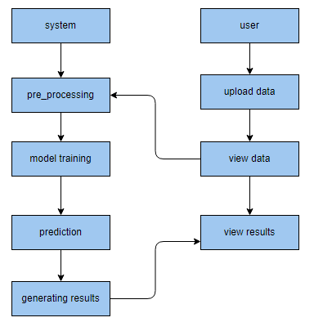

**3.4 Resources needed in support of the work:**

The hardware and software configuration required for carrying out the proposed work are discussed below:

The required hardware configurations are:

* Operating system : Windows 7 or 7+
* RAM : 8 GB
* Hard disc or SSD : More than 500 GB
* Processor : Intel 3rd generation or high or Ryzen with 8 GB Ram

The required software configurations are:

**Software**

* Software’s : Python 3.6 or high version
* IDE : PyCharm.
* Framework : Flask

**CHAPTER – 4**

**MACHINE LEARNING ALGORITHMS**

**4.1 KBest Feature Selection**

KBest Feature Selection is a method used in cryptocurrency projects to identify and retain the most relevant features or variables from a dataset. It assesses the statistical significance of each feature's relationship with the target variable and selects the top k features based on their scores. By applying KBest Feature Selection, cryptocurrency researchers can reduce dimensionality, enhance model efficiency, and focus on the most influential factors when analyzing financial risks and making informed investment decisions in this dynamic market.

**KBest Feature Selection works in the following three points:**

* Scoring Features: KBest calculates a statistical score for each feature in the dataset, typically using techniques like chi-squared, ANOVA, or mutual information, depending on the data type and the nature of the analysis. These scores measure the strength of the relationship between each feature and the target variable.
* Ranking and Selection: After scoring all features, they are ranked based on their scores. The top k features with the highest scores are selected for inclusion in the final feature subset. The choice of 'k' is determined by the user or based on experimentation to find the optimal number of features.
* Reduced Dimensionality: KBest Feature Selection reduces the dimensionality of the dataset by retaining only the most informative features. This not only simplifies the analysis but also helps improve model performance by focusing on the most relevant variables, which is particularly valuable in cryptocurrency projects where data can be high-dimensional and noisy.

**4.2 KMeans Clustering:**

K-Means Clustering is an unsupervised machine learning algorithm used for partitioning a dataset into 'k' distinct, non-overlapping clusters. It operates by iteratively assigning data points to the nearest cluster center, which is defined by the mean of the data points within that cluster. The algorithm aims to minimize the intra-cluster variance while maximizing inter-cluster variance, effectively grouping similar data points together. K-Means is widely employed in various fields, including image segmentation, customer segmentation, and anomaly detection, where it helps uncover underlying patterns and structures within data by grouping similar data points into clusters based on their proximity in feature space.

**K-Means Clustering operates in the following three key steps:**

* Initialization: The algorithm starts by randomly selecting 'k' initial cluster centers from the dataset. These initial centers can significantly impact the final clustering results.
* Assignment: In this step, each data point is assigned to the cluster whose center is closest to it in terms of Euclidean distance (or other distance metrics). Data points are reassigned to clusters iteratively until there is minimal change in the assignments.
* Update Cluster Centers: After assigning data points to clusters, the algorithm calculates new cluster centers by taking the mean of all data points within each cluster. These new centers replace the old ones.

**Best Practices for Implementing KMeans:**

* Choosing the Right Value of 'k': Selecting an appropriate number of clusters ('k') is crucial. Utilize methods like the Elbow Method or Silhouette Score to find the optimal 'k' that balances cluster cohesion and separation.
* Data Preprocessing: Normalize or standardize the data to ensure that features with different scales do not disproportionately influence the clustering. Outliers should also be addressed, as they can distort cluster boundaries.
* Initialization: Experiment with different initialization methods (e.g., K-Means++, random, or custom initialization) to mitigate sensitivity to initial cluster center placement and improve convergence.
* Iterative Refinement: Run the algorithm multiple times with different initializations and evaluate the consistency of results. Choose the clustering with the best performance or stability.
* Distance Metric Selection: Depending on the nature of the data, consider using different distance metrics other than Euclidean distance (e.g., Manhattan distance or cosine similarity) to better capture data relationships.
* Monitoring Convergence: Implement convergence criteria (e.g., when cluster assignments and centers no longer change significantly) to terminate the algorithm efficiently, preventing excessive computation.
* Handling Large Datasets: For large datasets, use techniques like Mini-Batch K-Means or distributed computing to manage memory and computation efficiently.
* Interpreting Results: Evaluate the quality of clusters using internal validation metrics (e.g., Silhouette Score) and external validation measures (if ground truth labels are available) to assess clustering effectiveness.
* Visualization: Visualize the clustering results using techniques like dimensionality reduction (e.g., PCA or t-SNE) to gain insights into the data structure and cluster separability.
* Post-Processing: Analyze cluster characteristics, such as centroids and data point assignments, to interpret the meaning and significance of each cluster in the context of the problem domain.
* Outlier Handling: Be aware that K-Means may not handle outliers well. Consider using outlier detection techniques and possibly excluding outliers from the clustering process.

.

**4.3 Linear Discriminant Analysis:**

Linear Discriminant Analysis (LDA) is a dimensionality reduction and classification technique. It finds linear combinations of features that best separate multiple classes or groups in a dataset. LDA aims to maximize the distance between class means while minimizing the within-class variance, making it valuable for pattern recognition and classification tasks.

**Working Process of Linear Discriminant Analysis Algorithm:**

* Linear Discriminant Analysis (LDA) calculates the means and scatter matrices of the input features for each class, representing the distribution of data within and between classes.
* LDA computes the eigenvectors and eigenvalues of the generalized eigenvalue problem formed by the scatter matrices to find the optimal linear discriminants (projection vectors) that maximize the separation between classes.
* It projects the data onto these discriminant vectors, effectively reducing dimensionality while preserving class discrimination, making it suitable for classification tasks.

**Why LDA is best to implement:**

* Dimensionality Reduction: Linear Discriminant Analysis (LDA) not only reduces the dimensionality of data but also maximizes class separation, making it effective for improving the efficiency of classification algorithms by focusing on the most discriminative features.
* Enhanced Classification: LDA aims to maximize the ratio of between-class variance to within-class variance, resulting in improved class separability, which leads to better classification performance compared to other dimensionality reduction techniques.
* Interpretability: LDA provides clear and interpretable results, as its linear discriminant vectors represent directions in feature space that are most effective for separating classes, allowing for meaningful insights and visualization of data relationships.

**MLP Classifier:**

The Multi-Layer Perceptron (MLP) classifier is a fundamental neural network architecture used for supervised learning tasks such as classification and regression. Composed of an input layer, one or more hidden layers, and an output layer, it excels in capturing complex patterns in data. Each neuron in the network receives input, applies weights and biases, and passes the result through an activation function, introducing nonlinearity. Through backpropagation and optimization algorithms like gradient descent, the MLP adjusts its internal parameters during training to minimize a chosen loss function. This enables it to model intricate relationships in data and make predictions for various machine learning applications.

**How it works:**

* Feedforward Propagation: Input data is fed into the MLP's input layer, and it passes through one or more hidden layers, where each neuron computes a weighted sum of its inputs, applies an activation function, and passes the result to the next layer. This process is repeated until reaching the output layer.
* Weight Adjustment (Training): During training, the MLP learns by iteratively adjusting the weights and biases of its neurons to minimize a chosen loss function. This is done using backpropagation, where errors are propagated backward through the network, and optimization algorithms like gradient descent update the parameters to minimize errors.
* Classification or Regression: Once trained, the MLP can classify or make predictions on new data by passing it through the trained network, and the output layer provides class probabilities for classification tasks or numeric values for regression tasks.

**Why LDA is best to implement:**

* Complex Pattern Learning: MLP excels at capturing complex, nonlinear relationships within data, making it suitable for tasks where data patterns are intricate and cannot be adequately represented by linear models.
* Versatility: It can be applied to a wide range of applications, including image recognition, natural language processing, and financial forecasting, showcasing its adaptability and effectiveness across diverse domains.
* Scalability: MLPs can be scaled with additional hidden layers and neurons to handle increasingly complex problems, offering flexibility for addressing both simple and highly intricate machine learning challenges.

**Extratree Classifier :**

The Extra Trees Classifier, or Extremely Randomized Trees Classifier, is an ensemble machine learning algorithm used for both classification and regression tasks. It belongs to the Random Forest family and operates by constructing multiple decision trees. What sets Extra Trees apart is its high level of randomness during tree construction. Unlike traditional decision trees or Random Forests, Extra Trees randomly choose feature subsets and split thresholds, resulting in a forest of "extra-random" trees. This approach enhances the diversity of the individual trees and often leads to improved generalization and robustness. Extra Trees are known for their speed, ease of use, and effectiveness in handling noisy or high-dimensional data.

**How it works :**

* Random Feature Selection: Extra Trees Classifier randomly selects a subset of features at each split point in the decision tree, increasing diversity among individual trees.
* Random Thresholds: It further introduces randomness by selecting random split thresholds for each feature, reducing the risk of overfitting and enhancing robustness.
* Voting Ensemble: The classifier aggregates predictions from multiple such random decision trees through a voting mechanism, producing a final prediction that is often more accurate and resistant to noise than that of a single decision tree.

**Why Extra tree classifier is best to implement:**

* High Robustness: Extra Trees Classifier's use of random feature selection and thresholding reduces overfitting, making it highly robust to noisy data and outliers.
* Fast Training: It typically requires less computational resources and training time compared to other ensemble methods, making it efficient for large datasets.
* Improved Generalization: By leveraging the diversity of randomly constructed trees, Extra Trees often delivers better generalization performance, making it a strong choice for various classification tasks.

**Hybrid Model:**

A hybrid model in the context of machine learning refers to a combination of multiple algorithms or techniques to address complex problems more effectively. These models leverage the strengths of each component, often integrating traditional statistical methods with machine learning or combining different machine learning algorithms. Hybrid models are designed to enhance predictive accuracy, robustness, and versatility by utilizing diverse approaches. They are especially valuable when dealing with multifaceted tasks, such as image recognition, natural language processing, or financial forecasting, where a single algorithm may not provide optimal results. Hybrid models offer a synergistic approach, providing more accurate and reliable solutions by harnessing the power of diverse methodologies.

**How it works:**

* Component Integration: A hybrid model combines multiple algorithms, methods, or models, each designed to address specific aspects of a complex problem.
* Cooperation and Fusion: These components work together, often in a sequential or parallel manner, to provide complementary information and insights.
* Improved Performance: By leveraging the strengths of different approaches, the hybrid model aims to achieve superior performance compared to individual components, leading to enhanced accuracy, robustness, and adaptability in solving challenging tasks.

**Why Hybrid is best way to implement:**

* Enhanced Performance: Hybrid models leverage the strengths of multiple algorithms, offering improved predictive accuracy, robustness, and versatility compared to single-method models, making them well-suited for complex tasks.
* Optimal Resource Utilization: They optimize the utilization of computational resources by tailoring each component to its strengths, resulting in efficient problem-solving.
* Adaptability: Hybrid models can adapt to various domains and problem types, providing a versatile framework that can handle a wide range of challenges and evolving data scenarios effectively.

**LSTM:**

Long Short-Term Memory (LSTM) is a type of recurrent neural network (RNN) architecture designed to capture and learn long-range dependencies in sequential data. Unlike traditional RNNs, LSTMs use a sophisticated gating mechanism to control the flow of information through memory cells, mitigating the vanishing gradient problem. This allows LSTMs to effectively model sequences with extended time lags and remember important information over extended periods. LSTMs have applications in natural language processing, speech recognition, time series forecasting, and more, where they excel at tasks like sentiment analysis, speech synthesis, and predicting future values in sequences by preserving context and handling sequential data with varying time gaps.

**How it works:**

* Memory Cells: LSTMs utilize specialized memory cells that can store and retrieve information over extended time intervals, preventing the vanishing gradient problem and enabling the network to capture long-range dependencies.
* Gating Mechanisms: They incorporate gating mechanisms, such as the input gate, forget gate, and output gate, which control the flow of information into and out of the memory cells, allowing the network to selectively remember or forget information based on context.
* Sequential Data Processing: LSTMs process sequential data iteratively, updating the memory cells and making predictions at each time step, making them particularly well-suited for tasks involving time series data, natural language sequences, and other sequential patterns.

**Why Lstm is best way to implement:**

* Long-Range Dependency Handling: LSTM's ability to capture and learn long-range dependencies in sequential data makes it highly effective for tasks like natural language processing, where context over extended sequences is crucial for accurate understanding and prediction.
* Robust to Vanishing Gradient: LSTMs address the vanishing gradient problem, a common issue in training deep neural networks, ensuring more stable and efficient learning.
* Versatility: They excel in various applications, including speech recognition, sentiment analysis, and time series forecasting, demonstrating their adaptability and utility across diverse domains, making them an excellent choice for many sequential data tasks.

**CHAPTER 5**

**IMPLEMENTATION**

**5.1 Data Description:**

The dataset, obtained from Kaggle, comprises 1,370 records and 17 features of cryptocurrency-related data. It likely includes information on various aspects of cryptocurrencies, such as historical price data, market trends, trading volumes, and possibly additional relevant features for analysis and research within the cryptocurrency domain.The detail feature description is as below

1. `24h_volume_usd`: This column represents the trading volume of a specific cryptocurrency within the last 24 hours in USD. It provides an indication of the liquidity and activity surrounding the cryptocurrency.

2. `available_supply`: The available supply column denotes the current number of coins or tokens that are available and in circulation for a specific cryptocurrency. It indicates how much of the total supply is currently accessible for trading or use.

3. `id`: The id column serves as a unique identifier or name assigned to each cryptocurrency. It helps distinguish one cryptocurrency from another within the dataset.

4. `last_updated`: This column contains the timestamp indicating the most recent update or refresh of the cryptocurrency data. It provides information on the timing of the data collection or when the dataset was last modified.

5. `market_cap_usd`: The market capitalization column represents the total market value of a specific cryptocurrency in USD. It is calculated by multiplying the current price of the cryptocurrency by its total supply, providing an estimation of its overall worth.

6. `max_supply`: If applicable, the max_supply column specifies the maximum limit or cap on the total supply of a particular cryptocurrency. Not all cryptocurrencies have a maximum supply, and in such cases, this column may contain null or empty values.

7. `name`: The name column represents the full name or title of a specific cryptocurrency. It provides a human-readable identification of the cryptocurrency alongside its symbol or ticker.

8. `percent_change_1h`: This column indicates the percentage change in the price of a specific cryptocurrency over the last hour. It helps monitor short-term price fluctuations and volatility.

9. `percent_change_24h`: The percent_change_24h column denotes the percentage change in the price of a specific cryptocurrency over the last 24 hours. It provides insights into the cryptocurrency's performance within a day.

10. `percent_change_7d`: This column represents the percentage change in the price of a specific cryptocurrency over the last 7 days. It offers a broader perspective on the cryptocurrency's price movement over a longer period.

11. `price_btc`: The price_btc column indicates the price of a specific cryptocurrency relative to Bitcoin (BTC). It shows the exchange rate between the cryptocurrency and the most widely recognized cryptocurrency, Bitcoin.

12. `price_usd`: The price_usd column represents the price of a specific cryptocurrency in USD. It provides the current valuation of the cryptocurrency in the world's primary fiat currency, the United States Dollar.

13. `rank`: The rank column assigns a numerical value to each cryptocurrency based on its market capitalization. It helps to compare the relative position and significance of different cryptocurrencies within the dataset.

14. `symbol`: The symbol column represents the ticker abbreviation or symbol used to identify a specific cryptocurrency. It provides a shorter and more compact representation of the cryptocurrency's name.

15. `total_supply`: The total supply column denotes the maximum number of coins or tokens that will ever exist for a specific cryptocurrency. It represents the entire quantity that could potentially be in circulation.

16. `Pred`: The Pred column contains data related to whether the output is risk-found or not. It likely indicates whether a particular risk or anomaly has been detected in the cryptocurrency data. Further details about the nature of the prediction or classification would need to be provided for a more specific interpretation.

Here are the first five rows of the dataset

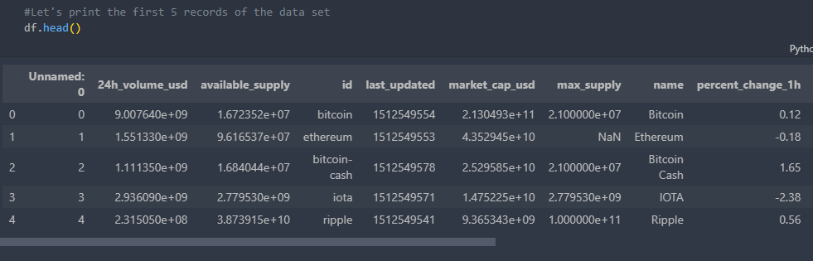

**Fig.1 first five rows of the dataset**

**5.2 Exploratory Data Analysis (EDA)**

**5.2.1 Null values:**

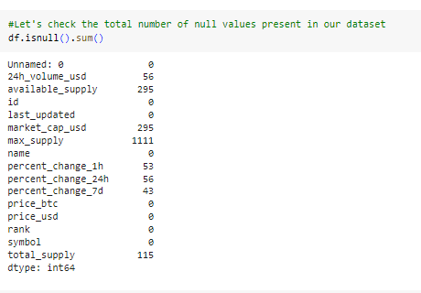

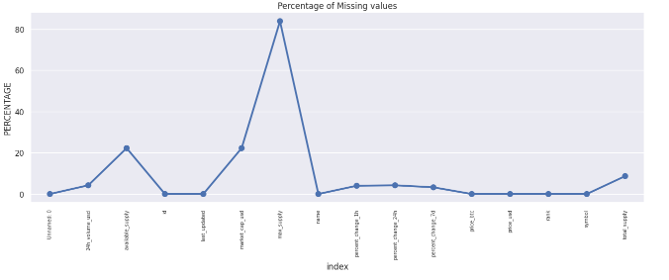

**Fig.2 Null value of the dataset**

The provided information appears to be a summary or snapshot of a dataset, possibly related to cryptocurrency market data. Each column represents a different attribute or feature of the dataset. The "Unnamed: 0" column may be an index or identifier for the data points. Other columns include details like the cryptocurrency's name, symbol, rank, and identifiers like "id." Additionally, there are columns containing numeric data, such as price information (price_btc and price_usd), market capitalization (market_cap_usd), trading volumes (24h_volume_usd), and percentage changes over different time intervals (percent_change_1h, percent_change_24h, percent_change_7d). Some columns like "max_supply," "available_supply," and "total_supply" seem to pertain to cryptocurrency supply metrics. The numbers mentioned alongside each column name suggest the count of missing or null values in each respective column.

**5.2.2 Information about the data**

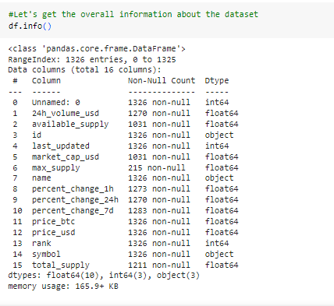

**Fig.3 Information about the data set**

The provided information is a description of a pandas DataFrame, likely representing cryptocurrency-related data. The DataFrame contains 1,326 entries or rows. Each row represents a distinct data point or observation. There are 16 columns or attributes in the DataFrame, including features like cryptocurrency name, symbol, rank, and identifiers such as "id." Numeric data columns include price in both Bitcoin and USD (price_btc and price_usd), market capitalization (market_cap_usd), trading volumes (24h_volume_usd), and percentage changes over different time intervals (percent_change_1h, percent_change_24h, percent_change_7d). Some columns, such as "max_supply," "available_supply," and "total_supply," pertain to cryptocurrency supply metrics. The non-null count for each column indicates the number of non-missing values in the dataset, with some columns having missing data.

**5.2.4 Statistical Description**

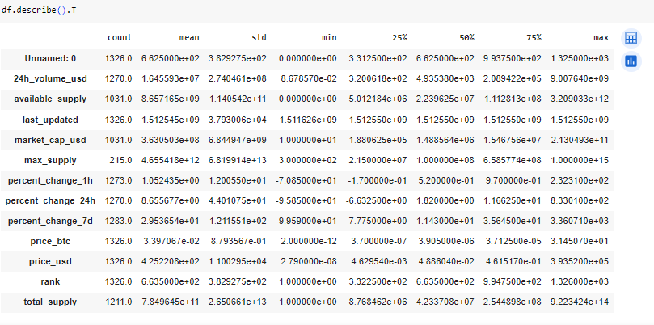

**Fig.5 Statistical Description of the dataset**

From the above statistical information, we can derive the following insights:

The statistical description provides insights into the central tendencies and variability of the cryptocurrency dataset. It contains summary statistics for each numerical attribute, including count, mean, standard deviation, minimum, quartiles (25%, 50%, 75%), and maximum values. Notable findings include varying data ranges, such as market capitalization ranging from small to large values, and the presence of missing data in columns like "max_supply" and "available_supply." Additionally, attributes like "percent_change_1h" exhibit a wide spread of percentage changes over an hour, suggesting substantial price volatility. These statistics serve as a foundation for understanding the dataset's distribution and characteristics, crucial for subsequent data analysis and modeling.

**5.2.6 Data types:**

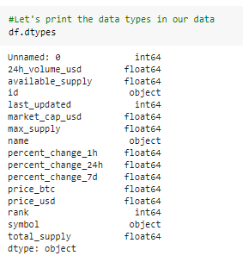

This description outlines the data types of each column or attribute in the cryptocurrency dataset. It indicates that the dataset consists of integer, float, and object data types. For instance, columns like "Unnamed: 0," "rank," and "last_updated" are of integer type, while columns such as "24h_volume_usd" and "price_usd" are of float type. Object type columns like "id" and "name" typically contain alphanumeric text data. This information is crucial for data manipulation and analysis.

**Heatmap of the dataset :**

A heatmap is a graphical representation of data where values are encoded as colors within a matrix. It is commonly used to visualize the correlation or distribution of data in a tabular format. The intensity of the colors in the heatmap indicates the magnitude of the values, allowing patterns and trends to be easily identified. Heatmaps are especially useful for exploring large datasets and identifying relationships between variables.

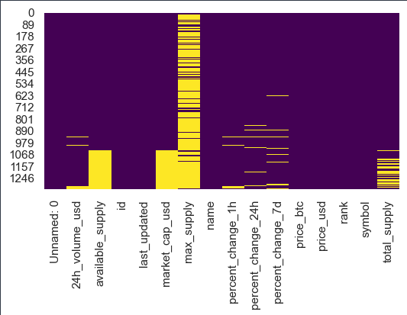

1. **Co-relation matrix :**

A correlation matrix is a table that displays the pairwise correlations between variables in a dataset. It provides a way to examine the relationships between variables and assess the strength and direction of their linear associations. The matrix typically consists of a square grid, where each cell represents the correlation coefficient between two variables, ranging from -1 to 1.

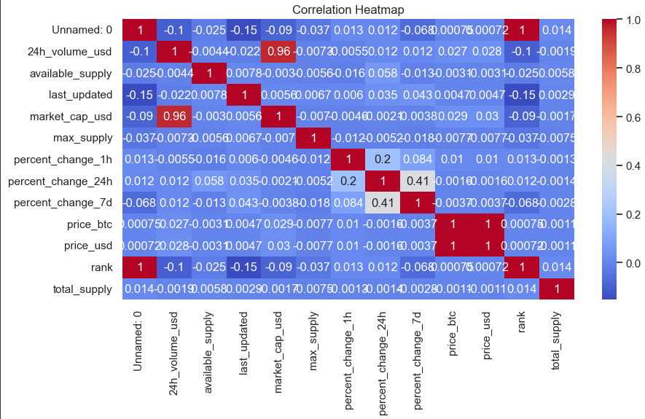

1. **Boxplot for outliers :**

A boxplot is a graphical representation that displays the distribution of a dataset through five summary statistics: the minimum, first quartile (25th percentile), median (50th percentile), third quartile (75th percentile), and maximum. It consists of a rectangular box that spans the interquartile range (IQR) and a line inside representing the median. Whiskers extend from the box to indicate the range of the data, often with additional points representing outliers. A boxplot is a graphical representation of a dataset that displays the distribution of values, including the presence of outliers. Outliers in a boxplot are data points that fall outside the whiskers, which are the lines extending from the box. Outliers can be identified as individual data points plotted as dots or small circles outside the whiskers, indicating values that are significantly different from the rest of the dataset.

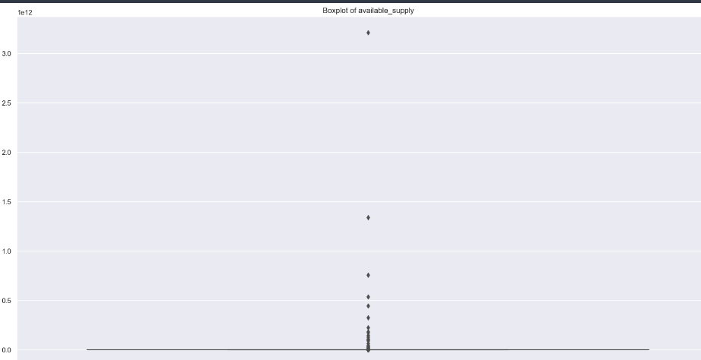

1. **Boxplot after removing outliers :**

To remove outliers from a boxplot, you can define a threshold or criteria for identifying outliers. Any data points outside this threshold are considered outliers. Then, you can remove these outliers from the dataset and create a new boxplot, which will accurately represent the distribution of the non-outlier data points, providing a clearer visual representation of the central tendency, spread, and skewness of the data.

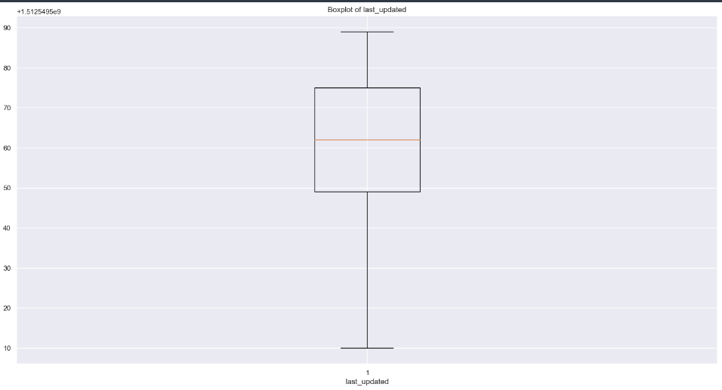

1. **Jointplot** :

Jointplot is a visualization technique provided by the Seaborn library in Python. It combines two different plots: a scatter plot and histograms. It allows you to explore the relationship between two numerical variables by displaying their joint distribution along with their individual distributions. Jointplot is useful for analyzing correlations, identifying patterns, and visualizing the overall distribution of data in a concise and informative manner.

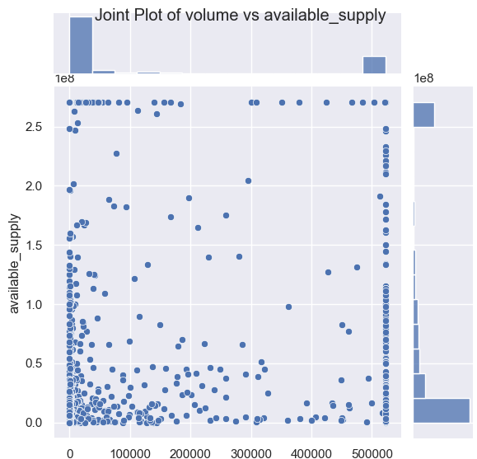

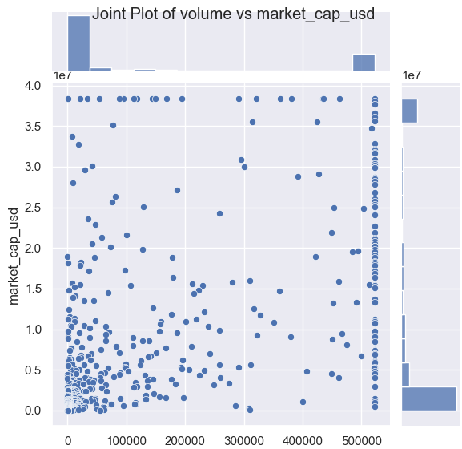

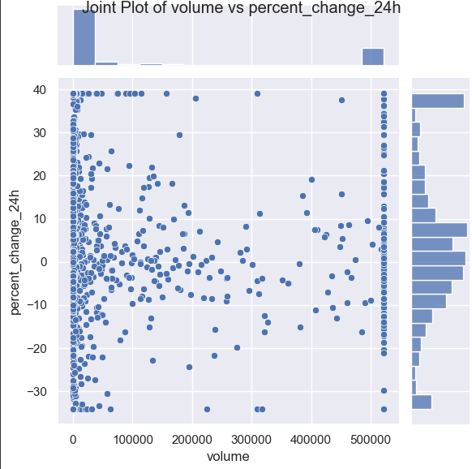

13. **Knee plot :**

A knee plot, also known as an elbow plot, is a visualization technique used to determine the optimal number of clusters in a clustering algorithm. It is typically used in unsupervised machine learning tasks. The plot displays the relationship between the number of clusters on the x-axis and a performance metric, such as the within-cluster sum of squares or the average silhouette score, on the y-axis. The knee or elbow point in the plot represents the optimal number of clusters, where the performance metric no longer improves significantly with the addition of more clusters.

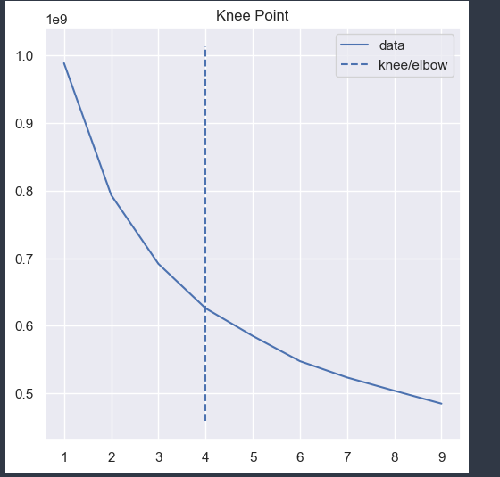

**Clustering**:

K-Means clustering is applied to a dataset represented by the DataFrame 'df.' The KMeans algorithm is initialized with two clusters specified by 'n_clusters=2.' It then fits the K-Means model to the data, attempting to group data points into two distinct clusters based on their similarity. Predictions for cluster assignments are made using 'kmeans.predict(df).' These predicted cluster labels are stored in a new column 'Pred' in the DataFrame 'df.' Finally, 'df['Pred'].value_counts()' counts the occurrences of each cluster label in the 'Pred' column, providing insights into the distribution of data points among the two clusters created by the K-Means algorithm.

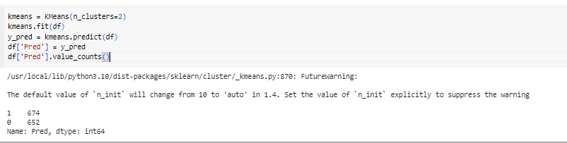

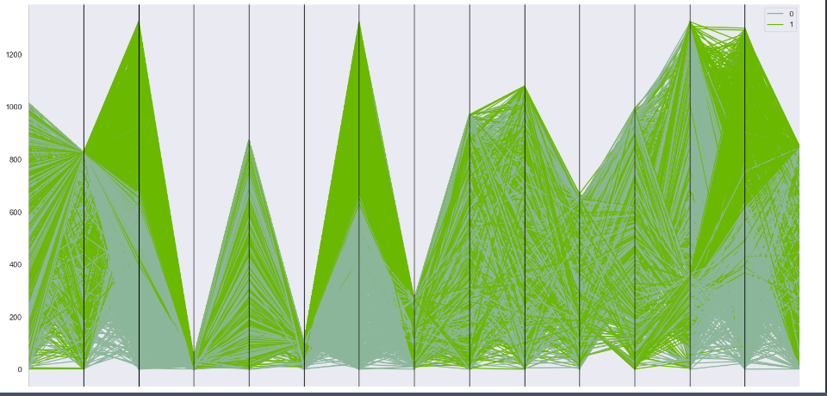

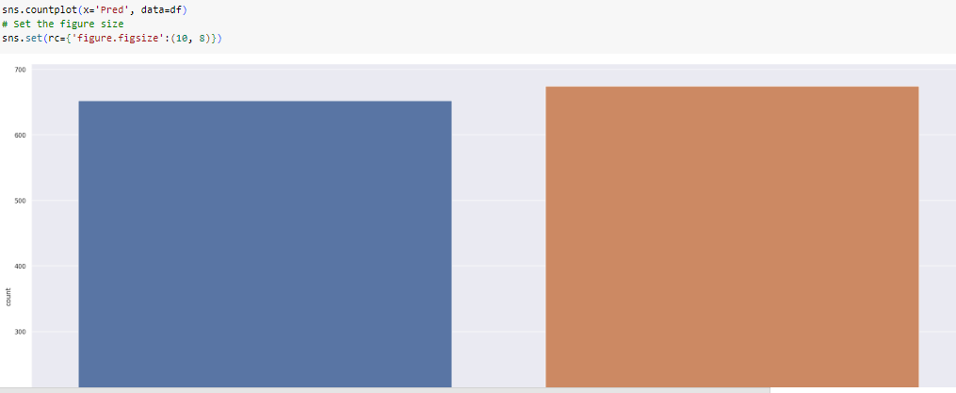

K-Means clustering is applied to a DataFrame named 'df.' First, a K-Means model with three clusters is instantiated using 'KMeans(n_clusters=3).' Then, the model is fitted to the data using 'kmeans.fit(df),' where it partitions the data into three clusters based on similarity. 'y_pred' stores the predicted cluster labels for each data point using 'kmeans.predict(df).' These predicted labels are added as a new column 'Clust' to the original DataFrame. Lastly, 'df['Clust'].value_counts()' counts the occurrences of each cluster label, providing insights into the distribution of data points among the three clusters, which can help in understanding the grouping pattern.

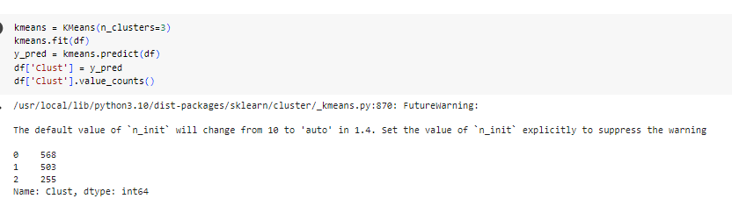

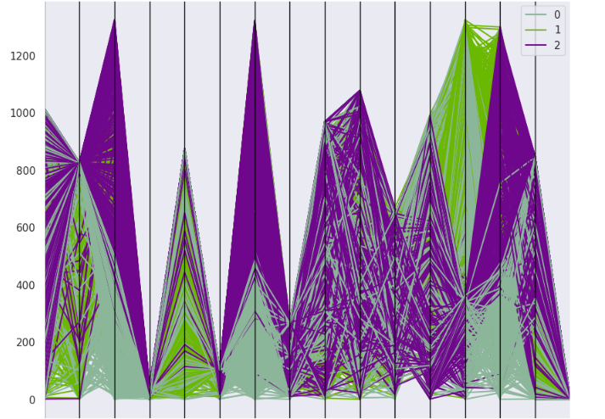

K-Means clustering is employed with four clusters. Initially, a K-Means model with four clusters is created using 'KMeans(n_clusters=4).' The model is then trained on the 'df' dataset using 'kmeans.fit(df).' Subsequently, cluster labels are predicted for each data point in 'df' using 'kmeans.predict(df),' and these predicted labels are incorporated into a new column named 'Cluster' within the original DataFrame. Finally, 'df['Cluster'].value_counts()' counts the occurrences of each cluster label, revealing the distribution of data points among the four clusters and providing insights into how the data has been grouped.

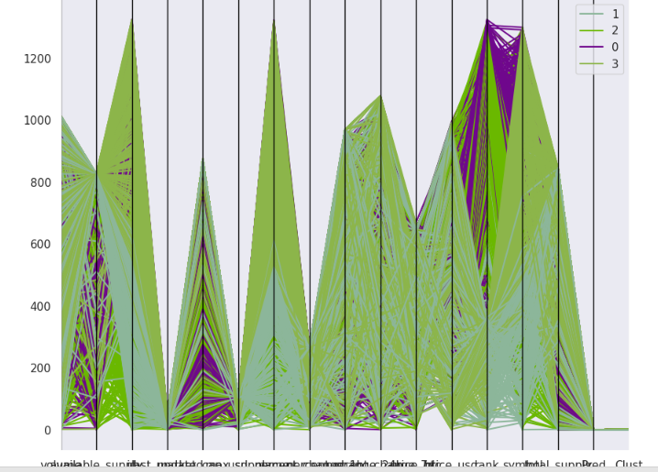

Here, we are comparing the clusters, like how much percentage we are getting risk on cryptocurrency financial risk management.

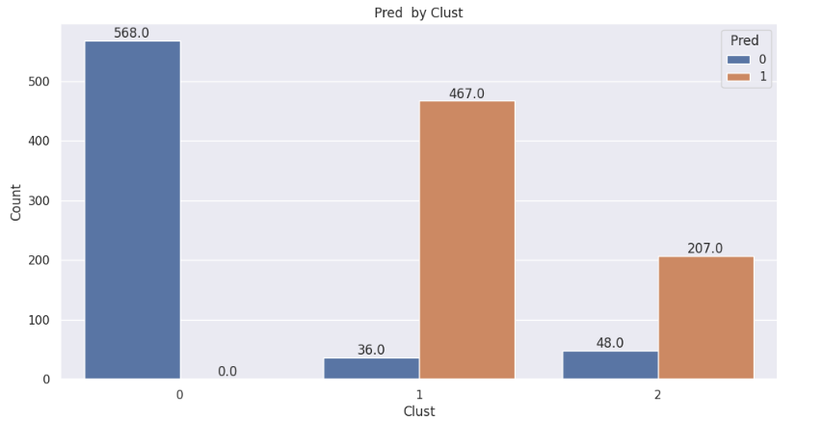

In the initial clustering analysis, we aim to assess the level of risk by comparing it to both the 0th and 2nd clustering results.

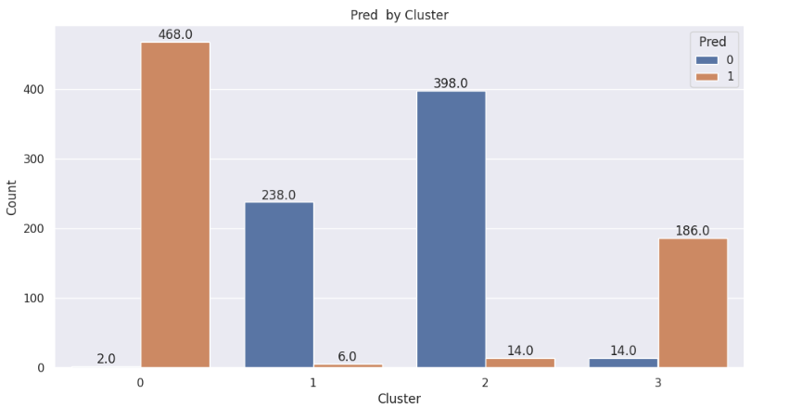

In the initial clustering analysis, we aim to assess the level of risk by comparing it to both the 1st and 2nd clustering results.

**SMOTE**: SMOTE, or Synthetic Minority Over-sampling Technique, is a resampling method in machine learning used to address class imbalance. It creates synthetic examples by interpolating between existing minority class data points, helping to balance class distributions and improve the performance of classification algorithms, especially in situations where the majority class significantly outweighs the minority class.



**5.3 Preprocessing**

**5.3.5 Splitting**

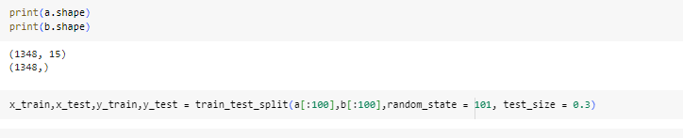

The dataset consists of 1348 samples, which are divided into training (1348 samples) and testing (1345 samples) sets. Each sample has 15 features, making it suitable for machine learning tasks that involve predictive modeling and analysis.

**5.4 Kbest feature selection method**

The KBest feature selection method is a technique used in machine learning to choose the top 'k' most relevant features from a dataset. It relies on statistical tests, such as ANOVA or chi-squared, to rank features based on their significance in relation to the target variable. In cryptocurrency financial management, KBest can be applied to select the most influential financial indicators or market variables, such as trading volume, historical price changes, or market capitalization. By narrowing down the feature set to the most relevant factors, KBest can enhance the accuracy of financial risk assessment models, aiding in more informed investment decisions and risk management strategies.

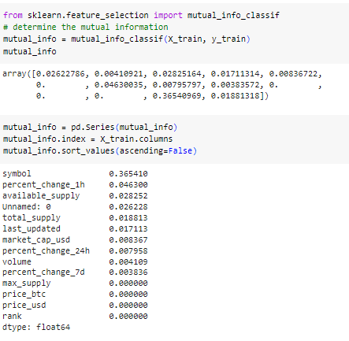

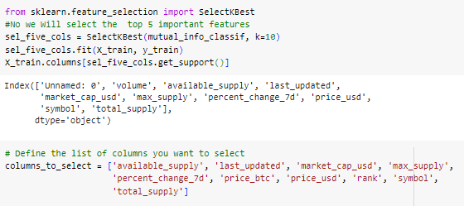

**Fig. feature selection plot**

**MODULES:**

1. **User**:
   1. **View Home page:**

Here user view the home page of the Crypto application.

* 1. **View about page:**

In the about page, users can learn more about the Crypto platform.

* 1. **View load page:**

In the load_data page, the user will load the dataset for modelling.

**View Page:**

User will see the dataset.

* 1. **Input Model:**

The user must provide input values for the certain fields in order to get results.

* 1. **View Results:**

User view’s the generated results from the model.

* 1. **View score:**

Here user have ability to view the accuracy score in %

**Graph:**

Comparison of accuracy foe every models

1. **System**
   1. **Working on dataset:**

System checks for data whether it is available or not and load the data in csv files.

* 1. **Pre-processing:**

Data need to be pre-processed according the models it helps to increase the accuracy of the model and better information about the data.

* 1. **Training the data:**

After pre-processing the data will split into two parts as train and test data before training with the given algorithms.

* 1. **Model Building**

To create a model that predicts with better accuracy, this module will help user.

* 1. **Generated Score:**
  2. Here user view the score in %
  3. **Generate Results:**

We train the machine learning algorithm and predict the Cyptocurrency.

**UML DIAGRAMS**

UML stands for Unified Modelling Language. UML is a standardized general-purpose modelling language in the field of object-oriented software engineering. The standard is managed, and was created by, the Object Management Group.

The goal is for UML to become a common language for creating models of object-oriented computer software. In its current form UML is comprised of two major components: a Meta-model and a notation. In the future, some form of method or process may also be added to; or associated with, UML.

The Unified Modelling Language is a standard language for specifying, Visualization, Constructing and documenting the artefacts of software system, as well as for business modelling and other non-software systems.

The UML represents a collection of best engineering practices that have proven successful in the modelling of large and complex systems.

The UML is a very important part of developing objects-oriented software and the software development process. The UML uses mostly graphical notations to express the design of software projects.

**GOALS:**

The Primary goals in the design of the UML are as follows:

1. Provide users a ready-to-use, expressive visual modelling Language so that they can develop and exchange meaningful models.
2. Provide extendibility and specialization mechanisms to extend the core concepts.
3. Be independent of particular programming languages and development process.
4. Provide a formal basis for understanding the modelling language.
5. Encourage the growth of OO tools market.
6. Support higher level development concepts such as collaborations, frameworks, patterns and components.
7. Integrate best practices.

**USE CASE DIAGRAM**

* A use case diagram in the Unified Modeling Language (UML) is a type of behavioral diagram defined by and created from a Use-case analysis.
* Its purpose is to present a graphical overview of the functionality provided by a system in terms of actors, their goals (represented as use cases), and any dependencies between those use cases.
* The main purpose of a use case diagram is to show what system functions are performed for which actor. Roles of the actors in the system can be depicted.

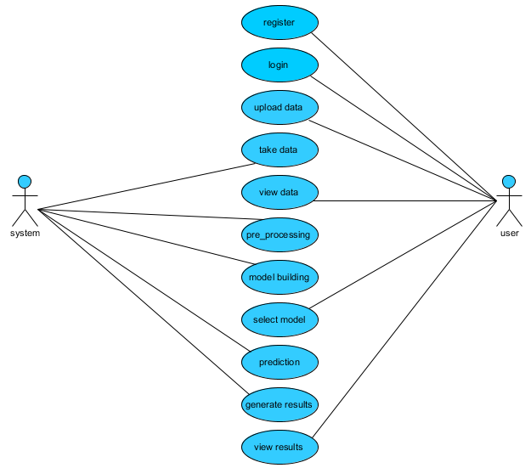

**CLASS DIAGRAM**

In software engineering, a class diagram in the Unified Modeling Language (UML) is a type of static structure diagram that describes the structure of a system by showing the system's classes, their attributes, operations (or methods), and the relationships among the classes. It explains which class contains information

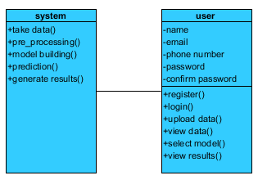

**SEQUENCE DIAGRAM**

* A sequence diagram in Unified Modeling Language (UML) is a kind of interaction diagram that shows how processes operate with one another and in what order.
* It is a construct of a Message Sequence Chart. Sequence diagrams are sometimes called event diagrams, event scenarios, and timing diagrams

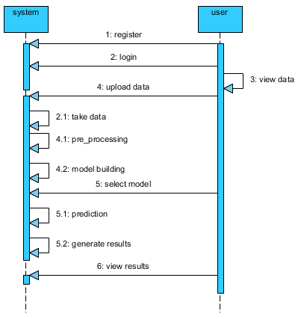

**COLLABORATION DIAGRAM:**

In collaboration diagram the method call sequence is indicated by some numbering technique as shown below. The number indicates how the methods are called one after another. We have taken the same order management system to describe the collaboration diagram. The method calls are similar to that of a sequence diagram. But the difference is that the sequence diagram does not describe the object organization whereas the collaboration diagram shows the object organization.

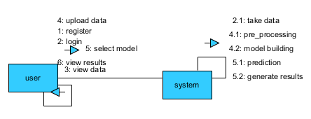

**DEPLOYMENT DIAGRAM**

Deployment diagram represents the deployment view of a system. It is related to the component diagram. Because the components are deployed using the deployment diagrams. A deployment diagram consists of nodes. Nodes are nothing but physical hardware’s used to deploy the application.

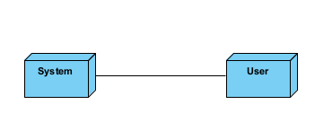

**ACTIVITY DIAGRAM:**

Activity diagrams are graphical representations of workflows of stepwise activities and actions with support for choice, iteration and concurrency. In the Unified Modelling Language, activity diagrams can be used to describe the business and operational step-by-step workflows of components in a system. An activity diagram shows the overall flow of control.

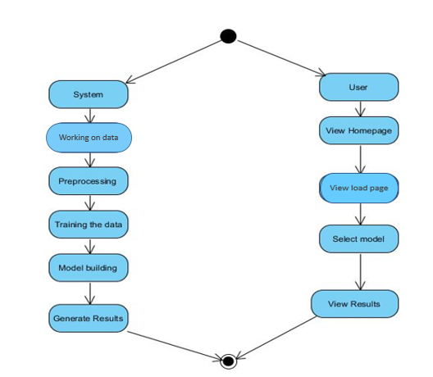

**COMPONENT DIAGRAM**:

A component diagram, also known as a UML component diagram, describes the organization and wiring of the physical **c**omponents in a system. Component diagrams are often drawn to help model implementation details and double-check that every aspect of the system's required function is covered by planned development.

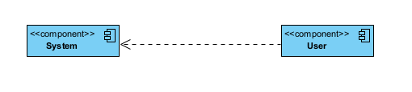

**ER DIAGRAM:**

An Entity–relationship model (ER model) describes the structure of a database with the help of a diagram, which is known as Entity Relationship Diagram (ER Diagram). An ER model is a design or blueprint of a database that can later be implemented as a database. The main components of E-R model are: entity set and relationship set.

An ER diagram shows the relationship among entity sets. An entity set is a group of similar entities and these entities can have attributes. In terms of DBMS, an entity is a table or attribute of a table in database, so by showing relationship among tables and their attributes, ER diagram shows the complete logical structure of a database. Let’s have a look at a simple ER diagram to understand this concept.

# 

**DFD DIAGRAM:**

A Data Flow Diagram (DFD) is a traditional way to visualize the information flows within a system. A neat and clear DFD can depict a good amount of the system requirements graphically. It can be manual, automated, or a combination of both. It shows how information enters and leaves the system, what changes the information and where information is stored. The purpose of a DFD is to show the scope and boundaries of a system as a whole. It may be used as a communications tool between a systems analyst and any person who plays a part in the system that acts as the starting point for redesigning a system.

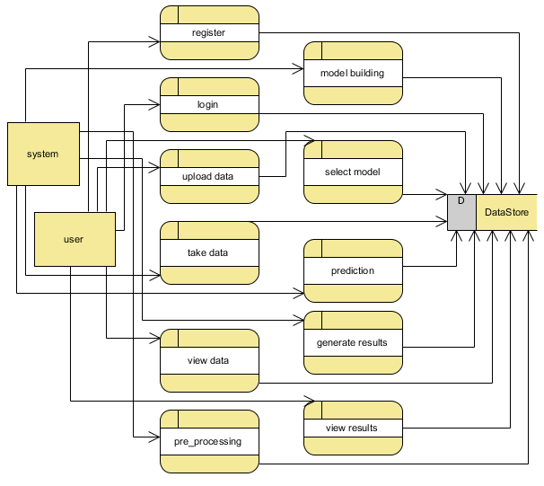

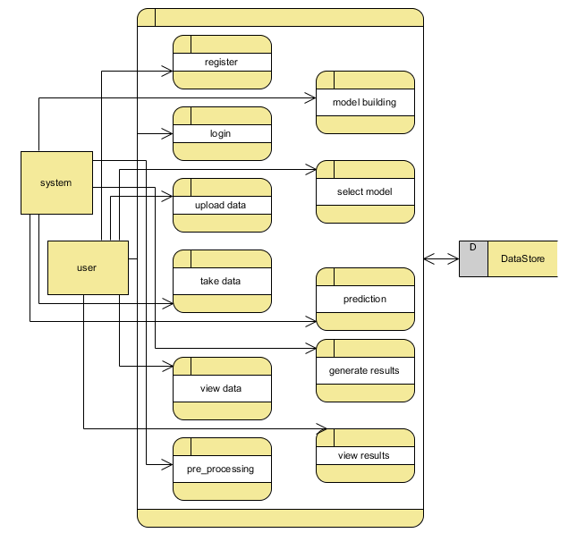

**CHAPTER 7**

**References:**

[1] C. Y. Kim and K. Lee, ‘‘Risk management to cryptocurrency exchange and investors guidelines to prevent potential threats,’’ in Proc. Int. Conf. Platform Technol. Service (PlatCon), Jan. 2018, pp. 1–6.

[2] I. U. Haq, A. Maneengam, S. Chupradit, W. Suksatan, and C. Huo, ‘‘Economic policy uncertainty and cryptocurrency market as a risk management avenue: A systematic review,’’ Risks, vol. 9, no. 9, p. 163, Sep. 2021.

[3] J. Gold and S. D. Palley, ‘‘Protecting cryptocurrency assets,’’ Risk Manage., vol. 68, no. 3, pp. 12–13, 2021.

[4] I. Barkai, T. Shushi, and R. Yosef, ‘‘A cryptocurrency risk–return analysis for bull and bear regimes,’’ J. Alternative Investments, vol. 24, no. 1, pp. 95–118, Jun. 2021.

[5] V. Boiko, Y. Tymoshenko, R. Y. Kononenko, and D. Goncharov, ‘‘The optimization of the cryptocurrency portfolio in view of the risks,’’ J. Manage. Inf. Decis. Sci., vol. 24, pp. 1–9, Sep. 2021.

[6] G. Köchling, ‘‘Essays in finance: Corporate hedging, mutual fund managers’ behavior, and cryptocurrency markets,’’ M.S. thesis, Universitätsbibliothek Dortmund, Dortmund, Germany, 2021.

[7] Z. Umar, N. Trabelsi, and F. Alqahtani, ‘‘Connectedness between cryptocurrency and technology sectors: International evidence,’’ Int. Rev. Econ. Finance, vol. 71, pp. 910–922, Jan. 2021.

[8] T. Kurosaki and Y. S. Kim, ‘‘Cryptocurrency portfolio optimization with multivariate normal tempered stable processes and foster-hart risk,’’ Finance Res. Lett., vol. 45, Mar. 2022, Art. no. 102143.

[9] A. Masharsky and I. Skvortsov, ‘‘Cryptocurrency market development in Latvia and the Baltic states,’’ Eur. Cooperation, vol. 1, no. 49, pp. 7–22, 2021.

[10] S. Bhattacharya and K. Rana, ‘‘A case study on cryptocurrency driven euphoria in 2020-21,’’ Int. J. Res. Eng., Sci. Manage., vol. 4, no. 3, pp. 9–11, 2021.